A story from the user’s click → through all the agents → back to the UI.

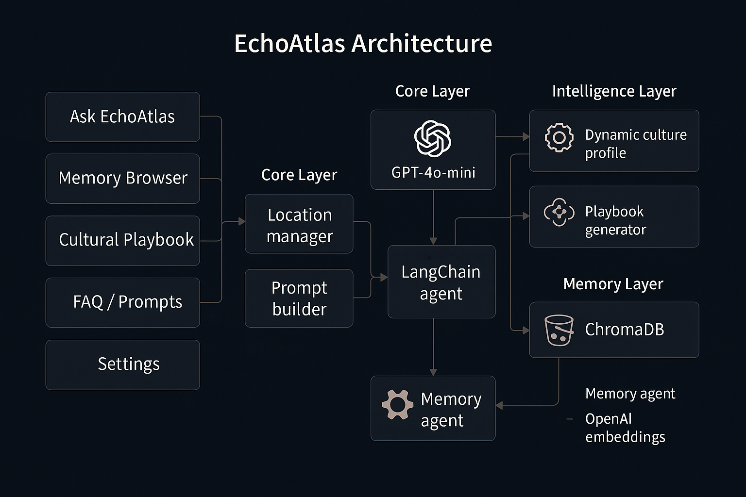

1. Big picture: one “Supervisor” + several specialists
Conceptually you have:
- Supervisor / Orchestrator
  - Implemented in run_agent(...) (in langchain_runner.py)
  - It is the one LLM that talks to the user.
  - It can call tools (which are our “agents”) when it needs help.
- Specialist agents (as tools)
  - Culture / Location agent – knows about regions, cities, tone, gestures.
  - Semantic phrase agent – focuses on crafting the actual sentence you should say.
  - Memory agent – reads/writes ChromaDB (store & recall conversations).
  - (Local version only) Speech agent – Vosk-based speech-to-text.
Each of these specialists is just a Python function wrapped as a LangChain tool, but architecturally we treat them as “agents with their own responsibility”.

2. Data flow from the UI down to the agents
Step 1 – UI collects context
On the Ask EchoAtlas page (app.py / previously app_glass_ultra.py):
- User selects:
  - region (e.g., France)
  - city (e.g., Paris or custom “Other”)
- User types a question (e.g., “How do I politely ask for recommendations at a café?”).
The UI then calls:
agent_output = run_agent(
user_input=user_input,
region=region,
location=city,
mode="Text",
context="default",
)
So the supervisor gets: question + region + city + mode + context.

Step 2 – Supervisor builds a rich prompt
Inside run_agent(...) you do roughly:
- Build a system prompt that says:
  - You are EchoAtlas, a cultural communication assistant.
  - Always respect the region & city.
  - You can call tools to:
    - Fetch culture cues,
    - Recall past similar interactions,
    - Store new interactions.
- Inject the location context:
  - “User is currently in , .”
  - “Provide phrasing, tone, gestures, cultural tip.”
- Attach tools (our agents) to the LLM:
  - culture_tool / location_tool
  - semantic_phrase_tool
  - memory_recall_tool
  - memory_store_tool (sometimes used post-hoc)
So the supervisor is now a tool-calling LLM agent:
It reasons: “To answer well, should I ask the culture agent? check memory? both?”

3. Specialist agents (as tools)
3.1 Culture / Location Agent
- Lives in something like culture_agent.py + location_agent.py.
- Given region + city, it returns:
  - Suggested tone (e.g., “Warm and respectful”)
  - Gesture / body language (e.g., “Hands together (Namaste)”)
  - Cultural tip (short 1–2 sentences)
  - Sometimes a seed phrase.
You also added a dynamic culture profile layer:
- generate_dynamic_culture_profile(region, city)
- Uses GPT-4o-mini to generate a JSON with:
  - phrase, gesture, tone, custom
- This is cached in st.session_state.dynamic_culture_cache.
- This is especially used when:
  - Region or city is “Other” or fully custom (no static profile).
So: static JSON + dynamic LLM profile → “Culture agent”.

3.2 Semantic Phrase Agent
- Lives in semantic_phrase_agent.py.
- Its job:
  - Take question + culture hints,
  - Output a single, natural sentence you can say.
- The supervisor can call this tool when it wants help turning “what” into “how to phrase it”.
(Even when the agent doesn’t call it explicitly, we kept the logic: the supervisor composes a phrase using similar style.)

3.3 Memory Agent
In memory_agent.py you built a full vector-memory agent:
- Uses ChromaDB with OpenAI embeddings (via CHROMA_OPENAI_API_KEY).
- Functions:
  - setup_memory_schema() – initialize collections on startup.
  - store_interaction(...) – stores:
    - region, city, user question, EchoAtlas answer
    - tone, gesture, custom tip, mode, context.
  - recall_similar(...) – given:
    - region, city, and optionally the current question,
    - returns top-k similar past interactions.
  - delete_memories_for_region(...) – used on the Memory page.
In the agent flow:
- When the supervisor starts answering:
  - It can call recall_similar(...) to get:
    - Past Q&A snippets, tone, gestures used.
  - These are passed as extra context.
- After the supervisor finalizes its answer:
  - The Streamlit app (not the LLM) calls store_interaction(...) to log the turn.
So memory is not just a history list; it’s a semantic embedding search per region + city.

3.4 Speech Agent (local only)
In our local app (not HF):
- speech_agent.py + VoskAudioProcessor handled:
  - WebRTC audio stream,
  - KaldiRecognizer from Vosk,
  - Building a transcript into st.session_state.transcript.
- Then, in mic mode, that transcript fed into run_agent(...).
In the HF version, we removed this entire agent, and kept only text input.

4. How a single request flows through all agents
Let’s simulate step by step:
Example:
Region = France, City = Paris,
User: “What is a polite way to ask the waiter for a recommendation?”
Step 1 – UI → Supervisor
- Ask EchoAtlas page collects:
  - region="France"
  - city="Paris"
  - user_input="What is a polite way..."
It calls run_agent(...).

Step 2 – Supervisor decides to call tools
Inside run_agent, the tool-calling LLM might internally do something like:
- Culture tool call
  - “CultureAgent, give me tone, gestures, cultural tips for Paris.”
  - Culture agent returns:
    - tone: “Warm but not overly familiar”
    - gesture: “Maintain eye contact briefly, avoid snapping or waving”
    - custom tip: “Always greet with ‘Bonjour’ before asking anything.”
- Memory recall tool call
  - “MemoryAgent, recall similar interactions where region=France, city=Paris.”
  - It returns several stored Q&A about:
    - how to order coffee,
    - how to complain politely,
    - how to greet staff.
- (Optionally) Semantic phrase tool
  - “SemanticAgent, craft a sample sentence for the user.”
The LLM orchestrator then combines:
- User’s question,
- Culture agent hints,
- Relevant memories,
- Phrase suggestions.

Step 3 – Supervisor returns a structured answer
The final agent_output you use in the app typically has:
{
"phrase": "Bonjour, que me recommandez-vous aujourd’hui ?",
"tone": "Warm and polite, not too casual",
"gesture": "Smile, make brief eye contact, and keep a relaxed posture.",
"custom": "In France, beginning with 'Bonjour' shows respect and is often expected before any request."
}
The UI:
- Shows phrase in the EchoAtlas Response card,
- Shows tone, gesture, custom under Cultural Insights,
- Logs this turn into memory via store_interaction(...).

5. What we’ve improved step by step (chronologically)
Here’s the “journey” of the architecture:
- Early version
  - One Streamlit page, mic + sounddevice + Vosk.
  - Single LLM prompt, not heavily modular.
- Multi-agent refactor
  - Introduced langchain_runner.py and langchain_tools.py:
    - Converted culture, semantic, memory functions into LangChain tools.
    - Added a Supervisor LLM that can call these tools in any order.
  - Memory agent got more structured: store, recall, delete.
- Chroma + Embeddings integration
  - Wired memory_agent to ChromaDB with OpenAI embeddings.
  - Scoped memories by:
    - region,
    - city (location),
    - mode/context.
  - Added Conversation Memory page to view and clear by city.
- Dynamic culture profiling for “Other” / custom cities
  - Added generate_dynamic_culture_profile(region, city):
    - LLM returns JSON: phrase, gesture, tone, custom.
  - Used when:
    - region/city are unknown or user enters custom values.
  - Cached in dynamic_culture_cache.
- Cultural Playbook
  - Added generate_cultural_playbook(...):
    - Combines base dynamic profile + all memories for that city.
    - Synthesizes a large JSON playbook (style, etiquette, do/don’t, examples).
  - Added export buttons:
    - JSON file
    - Markdown file (playbook_to_markdown).
- FAQ & Sample Prompts → Ask EchoAtlas integration
  - Built curated prompts by region/city.
  - Clicking a prompt:
    - Sets prefill_text,
    - Optionally sets selected_region + selected_city,
    - Marks prefill_just_set=True so Ask page doesn’t clear it on rerun.
- Hugging Face compatible version
  - Split code paths:
    - Local app: mic + Vosk multi-agent stack.
    - HF app: text-only, same supervisor & memory, no audio/mic agents.
  - Removed sounddevice, vosk, and webrtc for HF.
- Location + “Other” behavior
  - Refined selected_region / selected_city handling.
  - Added custom_city storage and logic so:
    - Custom city appears only when chosen under that region.
    - Location changes clear stale responses / prefill appropriately.

6. The essence of our multi-agent story
If you have to explain it in 1–2 sentences:
EchoAtlas uses a multi-agent LLM architecture.
A supervisor agent receives the user’s question plus region/city, then coordinates specialized agents for culture knowledge, semantic phrasing, and long-term memory (ChromaDB). Together they generate not just a sentence, but tone, gestures, and cultural tips that are personalized to location and adapted over time from your own past conversations.

